**Table of Contents**

**FPT International School**

--- o0o ---

**PROJECT REPORT**

**<FoodMate>**

Batch: T2009E

Semester: 2

Group: Dev5

* Nguyen Hoang Hiep
* Nguyen Viet Huong
* Tran Dinh Thiem
* Nguyen Xuan Manh
* Hoang Thanh Hai

**Hanoi - 09/2021**

1. Problem Definition 4

i. Introduction 4

ii. Implementation Environment 5

User Stories 7

1.2 Users 7

1.3 Staff 7

1.4 Admin 7

2. Database 9

2.1 DB Relationship Diagram 9

2.2 Table user 10

2.3 Table categories 10

2.4 Table products 10

2.5 Table user_carts 11

2.6 Table restaurant_reviews 11

2.7 Table restaurant_menu 11

2.8 Table restaurant_images 11

2.9 Table restaurants 11

2.10Table product_images 11

2.11Table order_details 12

2.12Table orders 12

2.13Table faqs 13

2.9 Table comments 13

3. UI\UX 14

A. User 14

1 Login & Register Form 14

2 Home Page 16

3 Food Shop 17

4 Discover restaurants 18

5 Place Order 19

6  User Cart 19

7  Orders 20

8  Order Detail 20

9 Cancel pending order 21

10 Account setting 22

11 Food detail 23

12 Restaurant detail 24

13 Contact us 25

14 Register restaurant 26

B. Staff 27

1 Dashboard 27

2 Order list 27

3 Order detail 28

4 Accept order 28

5 Reject order 29

6 Product list 29

7 Product edit 30

8 Add new product 30

9 Restaurant info 31

10 View earning history 31

C. Admin 32

1 Restaurant list 32

2 Restaurant detail 32

3 Browse registration 33

4 Delete restaurant 33

4. Summary 34

# **Problem Definition**

### Introduction :

FoodMate is a Web application that will act as an online bridge between customers/end users, restaurant staff and host. It will enable end users to browse through restaurant menus online and order food online. It will enable staff to register reservation, add/modify items in online menus, accept orders, and so on.

**Requirement Specification:**

1. **User functions :**

• Account Settings: Customers will be able to manage their accounts by using

options such as Create, Update, and Delete Profile. A profile can include

detailed information about the user, such as address.

• Home Page: The home page for customers should accept first name from the

user and display a personalized welcome message. At the top corner, the

user's first name should be displayed for the entire duration that the portal is

loaded. Popular and featured food items should be displayed on the home

page. Each food item can be presented as an image and a caption displaying

name, brief description, and price. Also, the restaurant name from where it

will be sent should be displayed.

• Search: Users can search for various food items such as breakfast, lunch, and

dinner items besides snacks. Search can also be performed based on cuisine

categories. Each food item can be presented as an image and a caption

displaying name, brief description, and price, along with restaurant name

from where it will be sent.

• Filter: Users can apply various filters on the displayed products. Filters can

include vegetarian, vegan, Chinese, Mexican, and so on.

• View Restaurants: View the list of all the restaurants sorted by their current

location.

• View Menu: View all the items available for a restaurant

• Place an Order: This menu option upon clicking should enable users to add

one or more items to the checkout cart.

• Checkout: User must enter delivery address at this point. Total computed bill

will be displayed to the user. You need not implement actual payment or

delivery functionality.

• History: View the list of all the past orders placed till date.

• Cancel Order: Cancel an already placed order that is not yet accepted and delivered.

• Submit Feedback: Users can submit their feedback regarding the restaurants and food.

• Register restaurant : Users can register a restaurant for e-commerce purpose in website.

1. **Restaurant staff functions :**

• View Orders: View list of open orders.

• Search Order: Staff can search for a specific order by providing the Order ID.

• Accept Order: Staff can confirm and accept an open order.

• Reject Order: If a specific order cannot be fulfilled staff should reject it and

provide the reason for rejection.

• Generate Reports: FoodMate will be able to generate and display different

kinds of reports such as most ordered item, largest quantity ordered, and so

on.

1. **Host functions :**

• View restaurants : View list of restaurants in website.

• Process restaurant status : Accept or refuse register request, set status for restaurants and delete restaurants.

### Implementation Environment

* Platform
* Windows 10
* Languages, libraries, framework
* HTML 5
* CSS3
* Javascript
* JQuery
* Bootstrap 4
* PHP
* Laravel 8
* Select2
* Application
* PhpStorm
* Chrome
* Microsoft Edge
* IE 5.0/ Netscape 6.0
* HTML editor
* MySQL
* Hardware requirement
* Intel Core i3/i5 Processor or higher
* 8 GB RAM or above
* Color SVGA
* 500 GB Hard Disk space
* Mouse
* Keyboard

# **User Stories**

## **Users**

### As a user I want to be able to register and login to my account so that I can place orders and register restaurant.

### As a user I want to be able to update my account setting so that I can manage my information.

### As a user I want to be able to view, filter and search for food in website so that I can find my favorite food for purchasing.

### As a user I want to be able to view restaurants and their menu so that I can find my favorite food for purchasing.

### As a user I want to be able to add food to cart and place order so that I can buy my favorite food.

### As a user I want to be able to view my orders history so that I can manage my orders.

1. As a user I want to be able to cancel my orders so that I can stop buying food when I need.
2. As a user I want to be able to give feedback to food and restaurants so that I can review and recommend them for other people.
3. As a user I want to be able to register a restaurant in website so that I can sell food online .

## **Restaurant staff**

### As a restaurant staff I want to be able to create, view, update, delete the food of my restaurant so that I can manage foods of my restaurant.

### As a restaurant staff I want to be able to view, filter orders of my restaurant so that I can manage orders.

### As a restaurant staff I want to be able to accept or reject orders so that I can reply to customer about their orders.

### As a restaurant staff I want to be able to update my restaurant information so that I can manage my restaurant information.

## **Admin**

### As a admin I want to be able to view restaurant list in my website so that I can manage those restaurants.

### As a admin I want to be able to process restaurant status, accept or refuse register request, set status for restaurants and delete restaurants so that I can manage restaurants.2. Database

## **2.1 DB Relationship Diagram**foodmate-db

## **2.2 Table: users**

|  |  |  |  |
| --- | --- | --- | --- |
| **Column Name** | **Data Type** | **Constraint** | **Description** |
| id | int | PK | Primary key of the table |
| name | varchar(255) | Not null | User name |
| email | Varchar(255) | Not null | User email |
| password | Varchar(255) | Not null |  |
| address | text | Nullable | User address |
| telephone | Varchar(10) | Nullable | User telephone |
| restaurant_id | int | Nullable | Restaurant id if user is a owner of a restaurant |
| avatar | Varchar(255) | Nullable | User avatar image path |
| role | int | Nullable | ( 0. host | 1 .user | 2.staff ) |

## **2.3 Table: categories**

|  |  |  |  |
| --- | --- | --- | --- |
| **Column Name** | **Data Type** | **Constraint** | **Description** |
| id | int | PK | Primary key of the table |
| cate_name | varchar(255) |  |  |
|  |  |  |  |

## **2.4 Table: products**

|  |  |  |  |
| --- | --- | --- | --- |
| **Column Name** | **Data Type** | **Constraint** | **Description** |
| id | int | PK | Primary key of the table |
| name | Varchar(255) |  | Product name |
| description | text | Nullable | Product description |
| status | int |  | Product status ( 1 : in stock, 0 : out stock) |
| price | double |  | Product price |
| cate_id | int | FK | Product category |
| discount | double | Nullable | Discount price |
| tag | Varchar(255) | Nullable |  |
| restaurant_id | int | FK | Product belongs to a restaurant |
| featured | tinyint | Default ‘0’ | Set product as featured ( 0. normal, 1. featured ) |
| rating | double | Default ‘0’ | Product rating |
| is_deleted | int | Default ‘0’ | If product is deleted by staff ( 0. no, 1. yes ) |

## 2.5 Table: user_carts

|  |  |  |  |
| --- | --- | --- | --- |
| **Column Name** | **Data Type** | **Constraint** | **Description** |
| id | int | PK | Primary key of the table |
| user_id | int |  |  |
| product_id | int | FK |  |
| qty | int |  | Quantity of a product in cart |
| restaurant_id | int | FK |  |
| order_id | int | FK | Belongs to a tempt order |
| total | double |  | Total of a product in cart |

## 2.6 Table : restaurant_reviews

|  |  |  |  |
| --- | --- | --- | --- |
| **Column Name** | **Data Type** | **Constraint** | **Description** |
| id | int | PK | Primary key of the table |
| restaurant_id | int | FK | Belongs to a restaurant |
| user_id | int | FK |  |
| messages | text |  | Review message |
| rate | int |  | Rating ( range [ 1 - 5 ] ) |

## 2.7 Table: restaurant_menu

|  |  |  |  |
| --- | --- | --- | --- |
| **Column Name** | **Data Type** | **Constraint** | **Description** |
| id | int | PK | Primary key of the table |
| restaurant_id | int | FK |  |
| cate_id | int | FK |  |
|  |  |  |  |

## 2.8 Table: restaurant_images

|  |  |  |  |
| --- | --- | --- | --- |
| **Column Name** | **Data Type** | **Constraint** | **Description** |
| id | int | PK | Primary key of the table |
| restaurant_id | int | FK |  |
| path | Varchar(255) |  | Restaurant image path |

## 2.9 Table: restaurants

|  |  |  |  |
| --- | --- | --- | --- |
| **Column Name** | **Data Type** | **Constraint** | **Description** |
| id | int | PK | Primary key of the table |
| restaurant_name | int |  | Name of restaurant |
| address | Varchar(255) |  |  |
| business_license | Varchar(255) |  |  |
| telephone | Varchar(10) |  |  |
| email | Varchar(255) |  |  |
| owner_name | Varchar(255) |  |  |
| tel_owner | Varchar(10) |  |  |
| avatar | Varchar(255) |  |  |
| user_id | int | FK |  |
| package | int | Default ‘0’ |  |
| status | int | Default ‘1’ | ( 1. pending, 2. wait for checkout, 3. active, 4. expired, 5. stop working) |
| rating | double | Default ‘0’ |  |
| stop | int | Default ‘0’ | 1. Working, 1. Stop) |
| start_date | date | Nullable | Start date of package |
| end_date | date | Nullable | End date of package |

## 2.10 Table: product_images

|  |  |  |  |
| --- | --- | --- | --- |
| **Column Name** | **Data Type** | **Constraint** | **Description** |
| id | int | PK | Primary key of the table |
| product_id | int | FK |  |
| path | Varchar(255) |  | product image path |

## 2.11 Table: order_details

|  |  |  |  |
| --- | --- | --- | --- |
| **Column Name** | **Data Type** | **Constraint** | **Description** |
| id | int | PK | Primary key of the table |
| user_id | int |  |  |
| product_id | int | FK |  |
| qty | int |  | Quantity of a product in a order |
| restaurant_id | int | FK |  |
| order_id | int | FK | Belongs to an order |
| total | double |  | Total of a product in a order |

## 2.12 Table: orders

|  |  |  |  |
| --- | --- | --- | --- |
| **Column Name** | **Data Type** | **Constraint** | **Description** |
| id | int | PK | Primary key of the table |
| full_name | Varchar(255) |  |  |
| email | Varchar(255) |  |  |
| phone | Varchar(10) |  |  |
| address | text |  |  |
| status | Varchar(255) |  | ( in cart, pending, processing, on-delivery, delivered, canceled, rejected) |
| user_id | int | FK | Total of a product in cart |
| restaurant_id | int | FK |  |
| delivery_estimated | datetime |  | Estimated datetime for delivery |
| delivery_time | datetime |  | Real delivered time |
| extra_info | text |  | Information about order (reason of cancellation, rejection … ) |
| total | double |  |  |
| delivered_confirm | text |  | Path of delivered confirmation image |

## 2.13 Table: faqs

|  |  |  |  |
| --- | --- | --- | --- |
| **Column Name** | **Data Type** | **Constraint** | **Description** |
| id | int | PK | Primary key of the table |
| title | text |  |  |
| content | text |  |  |

## 2.14 Table: comments

|  |  |  |  |
| --- | --- | --- | --- |
| **Column Name** | **Data Type** | **Constraint** | **Description** |
| id | int | PK | Primary key of the table |
| product_id | int | FK | Belongs to a product |
| user_id | int | FK |  |
| messages | text |  | Review message |
| rating | int |  | Rating ( range [ 1 - 5 ] ) |
| email | Varchar(255) |  |  |
| name | Varchar(255) |  |  |
|  |  |  |  |

# 3. **UI\UX**

1. **USER**

## Login & register form

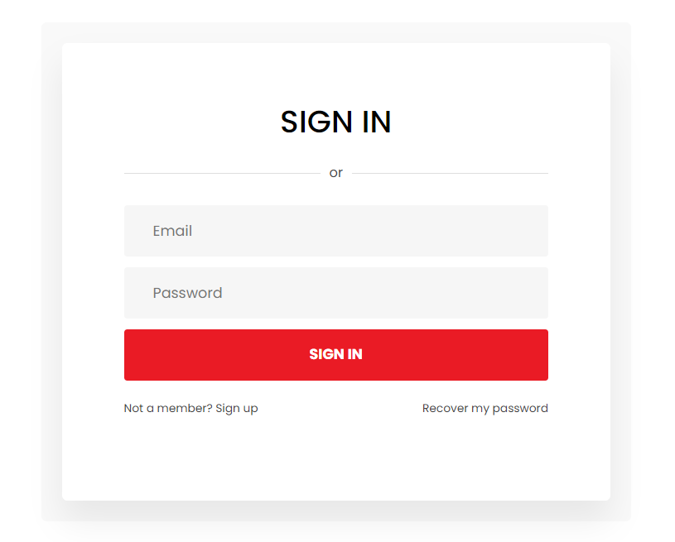

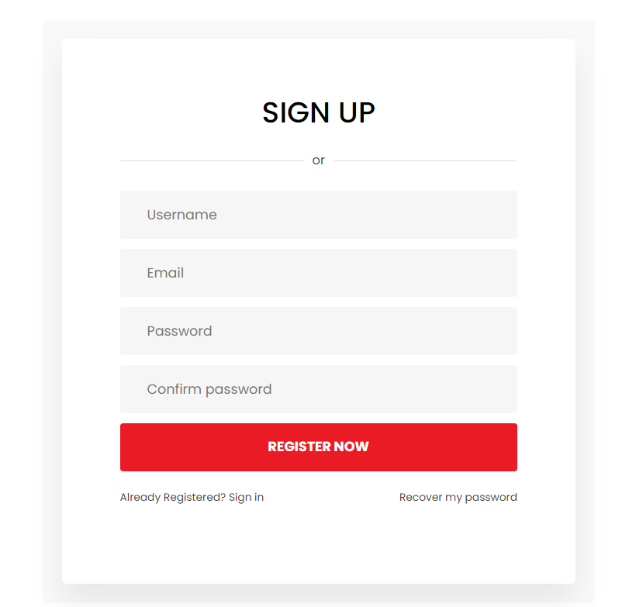

## User Home page

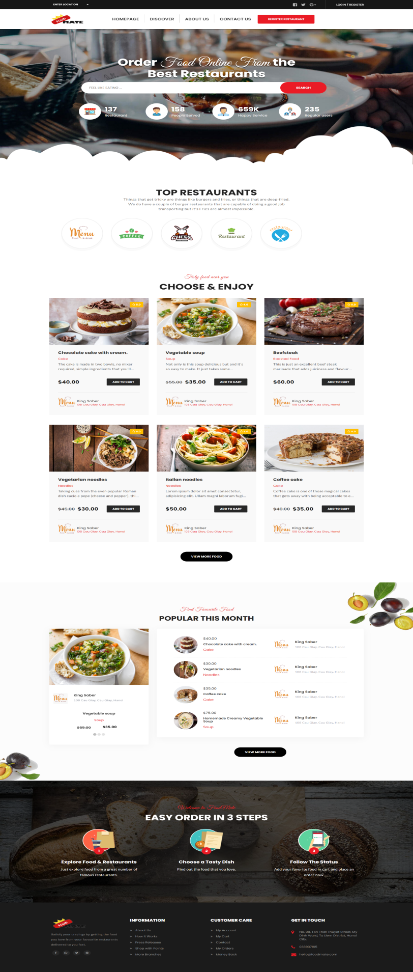

## Food shop

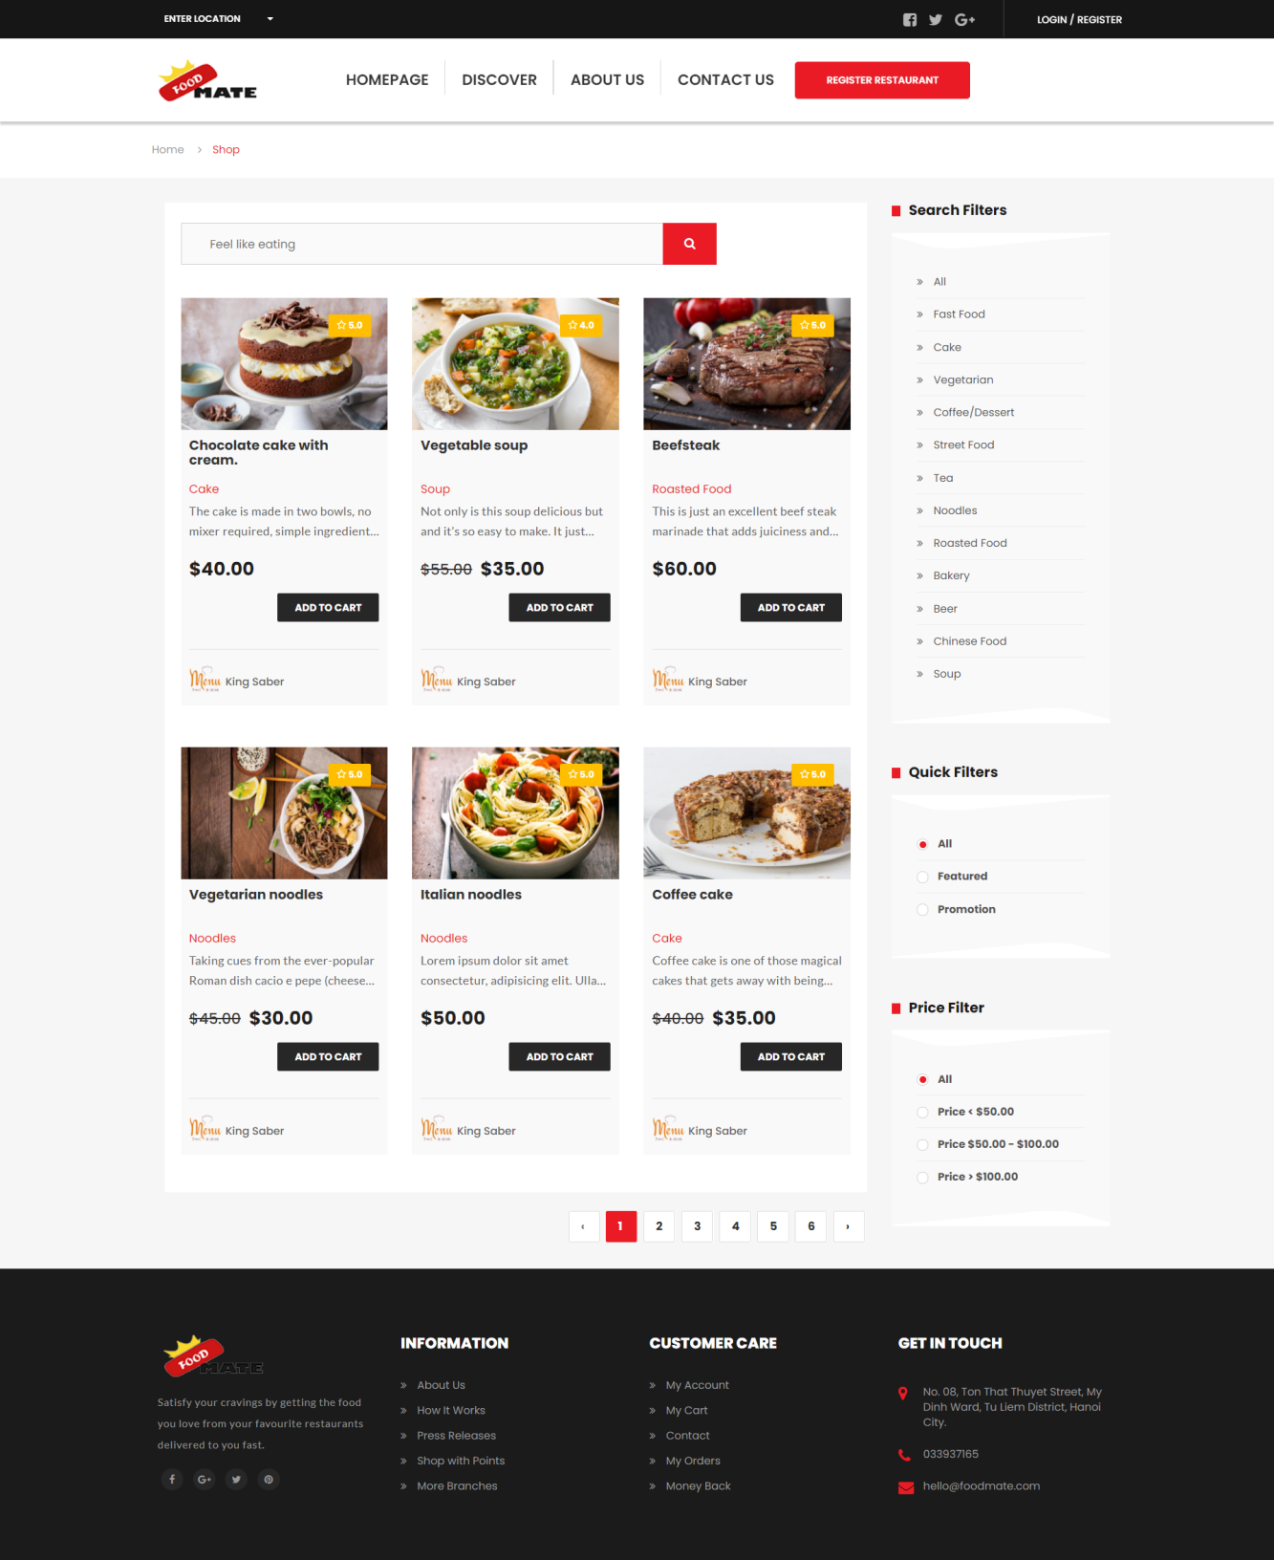

## Discover restaurants

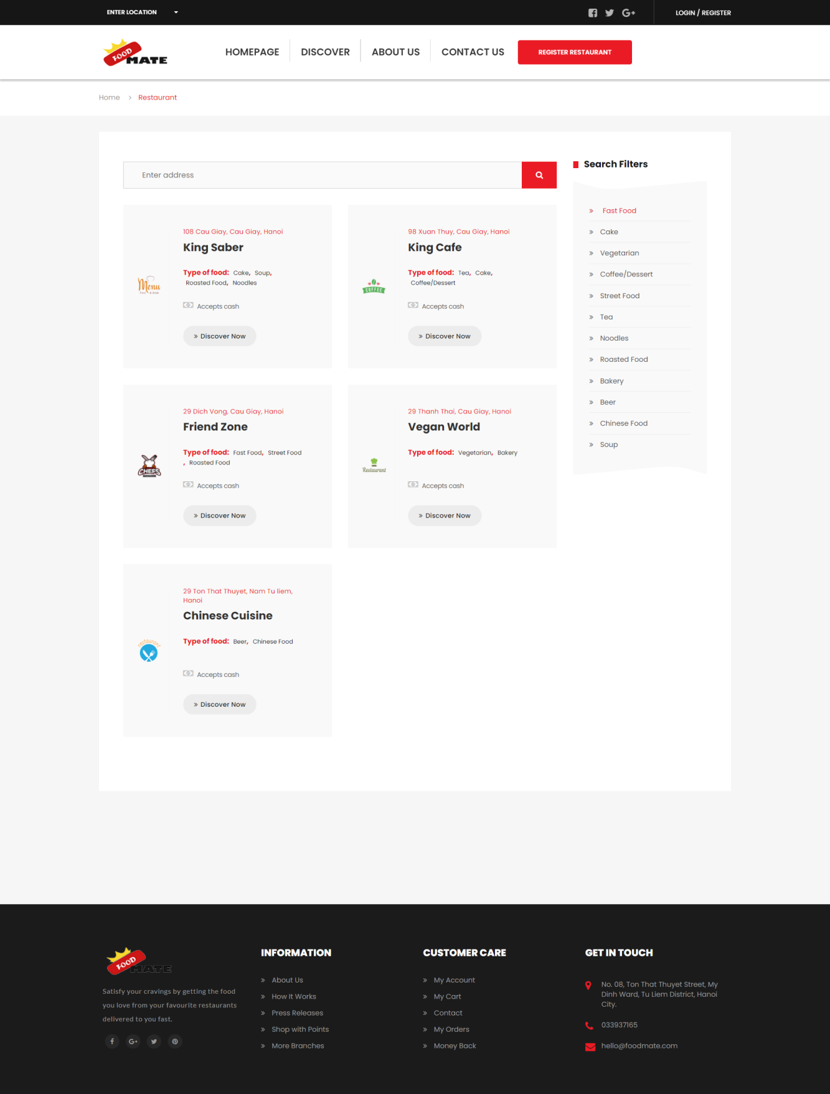

## User cart

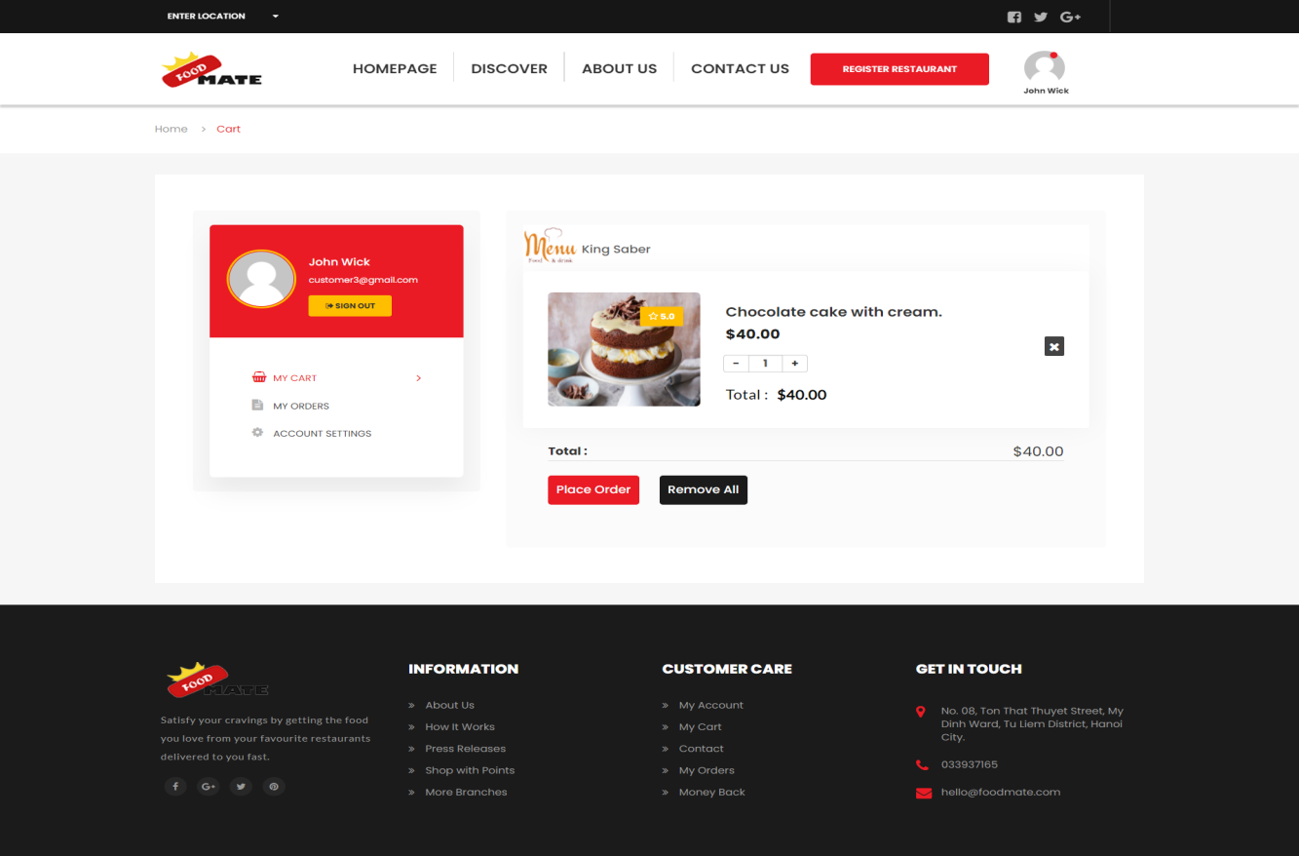

## Place order

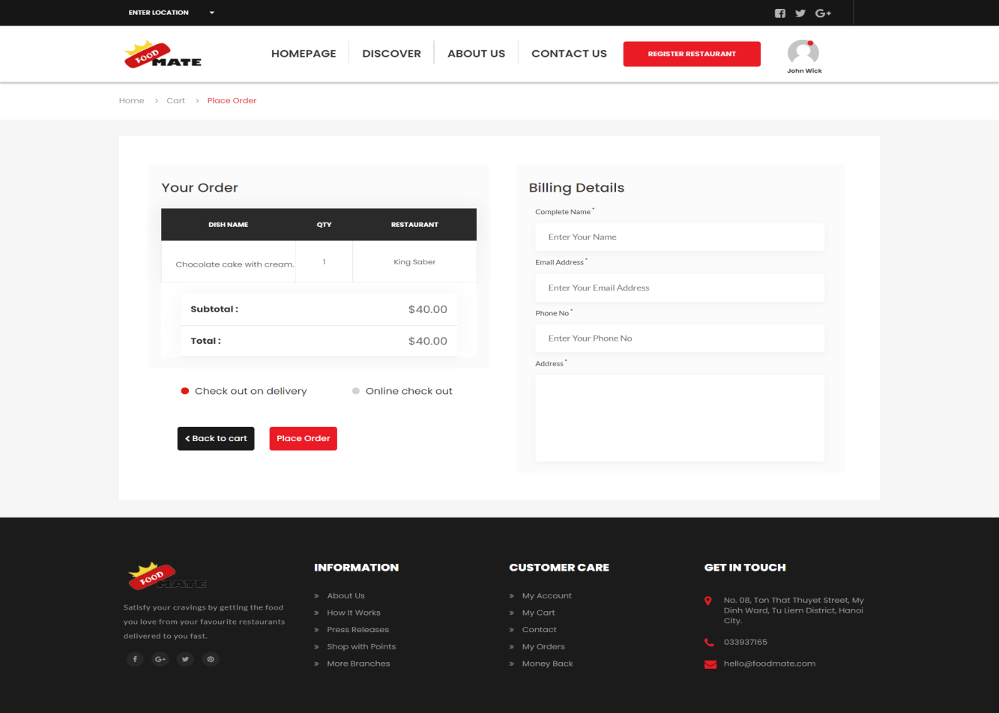

## User orders

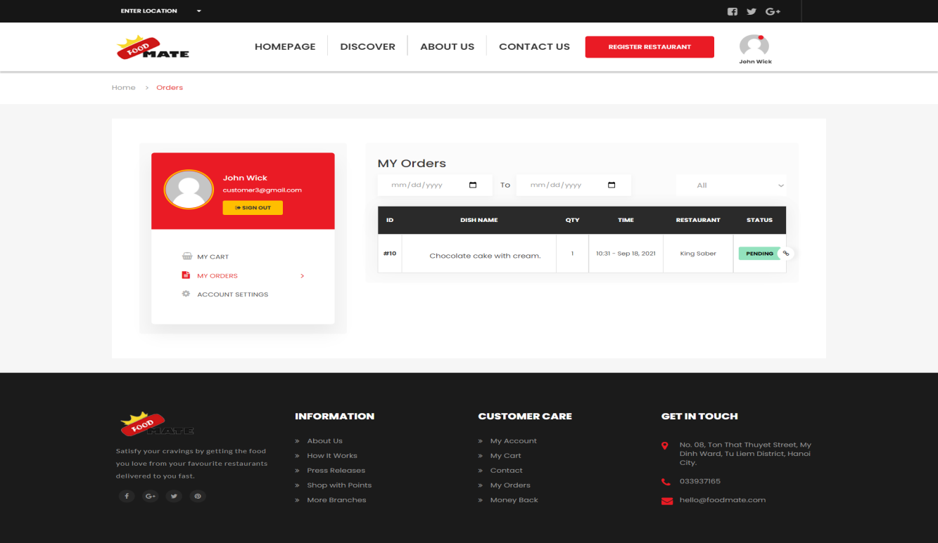

## Order detail

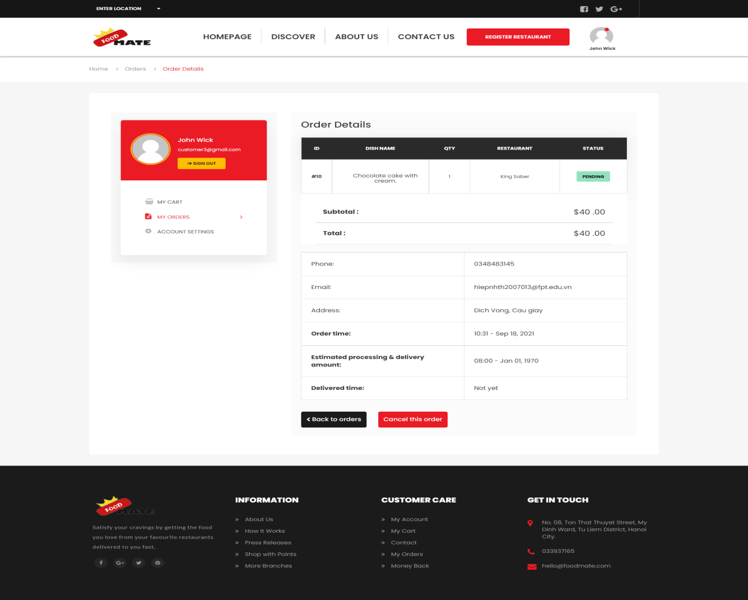

## Cancel pending order

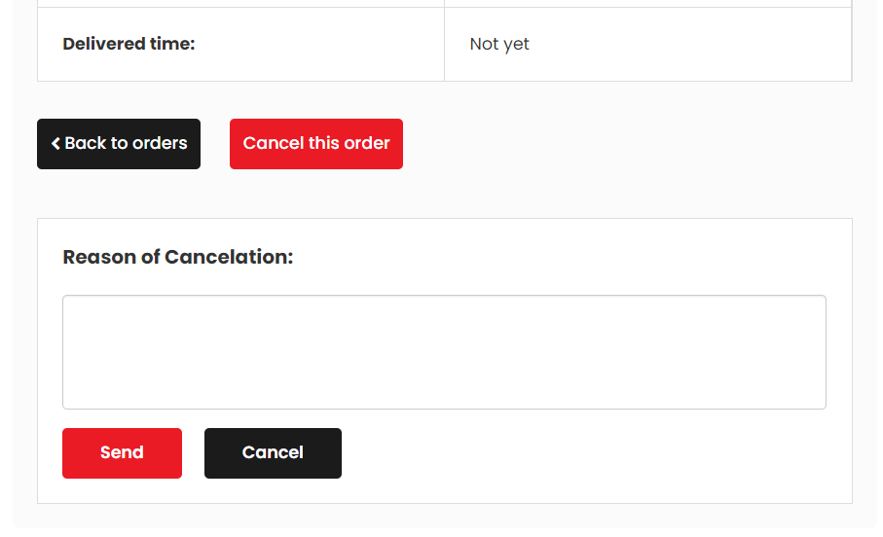

## **Account setting**

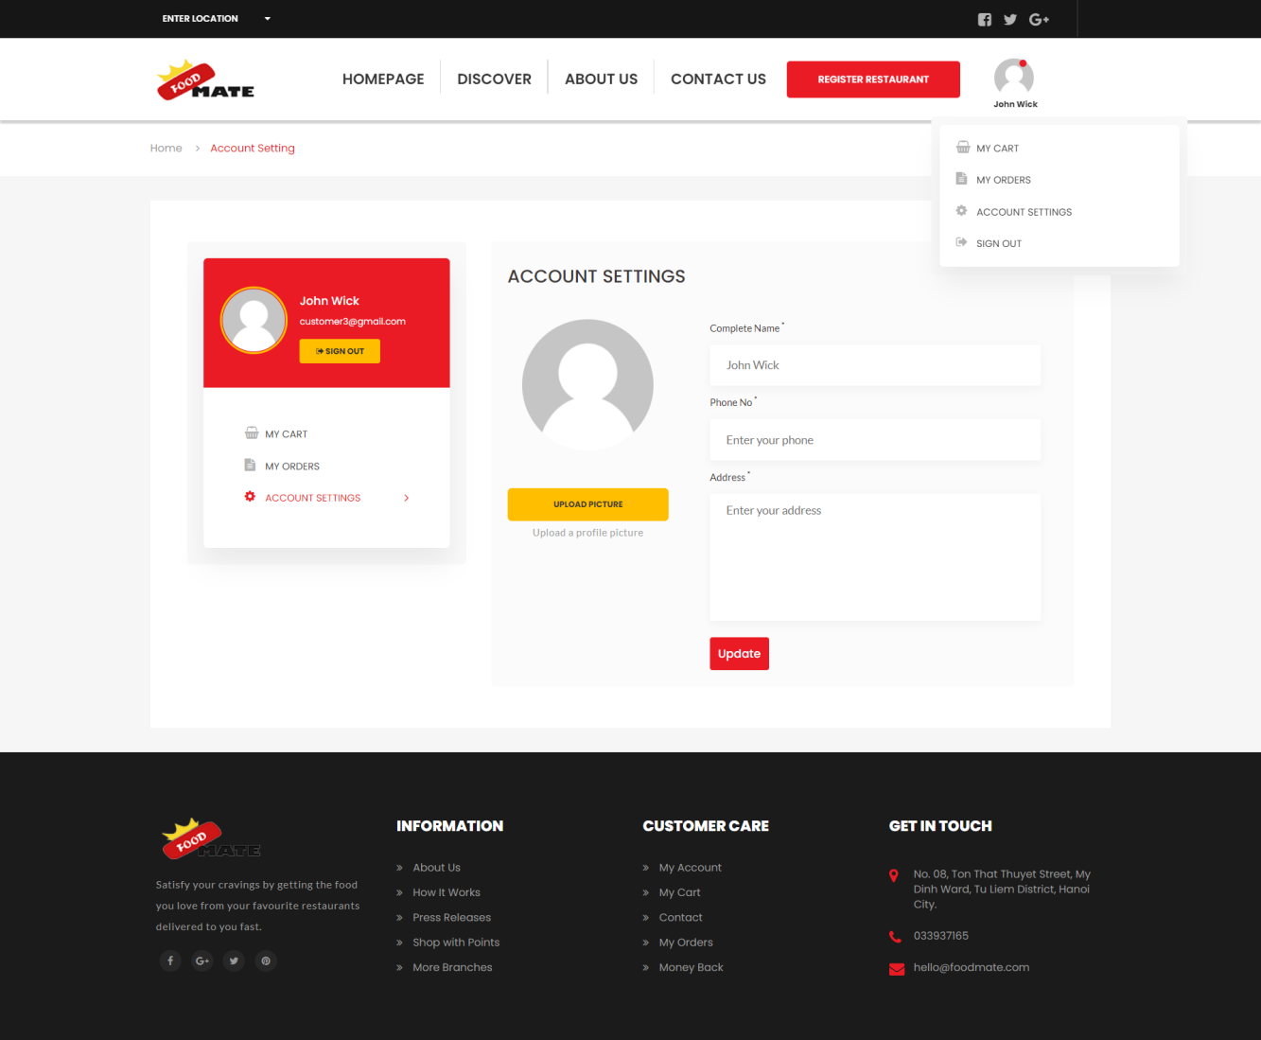

## **Food detail**

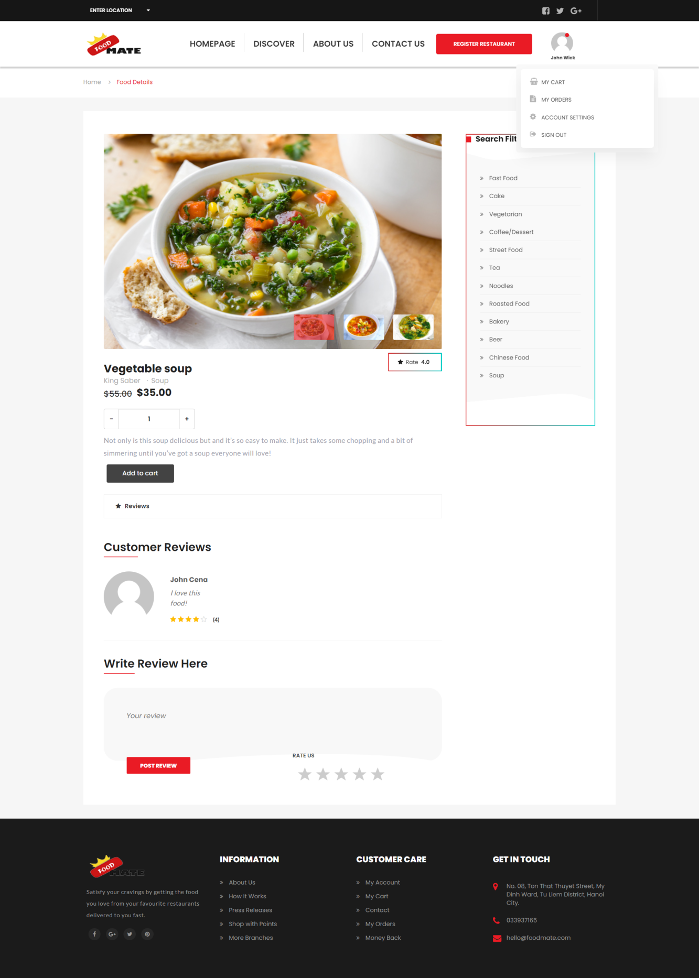

## **Restaurant detail**

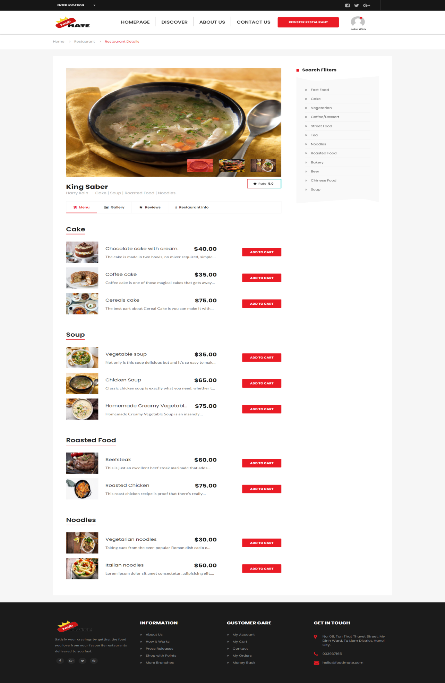

## Contact us

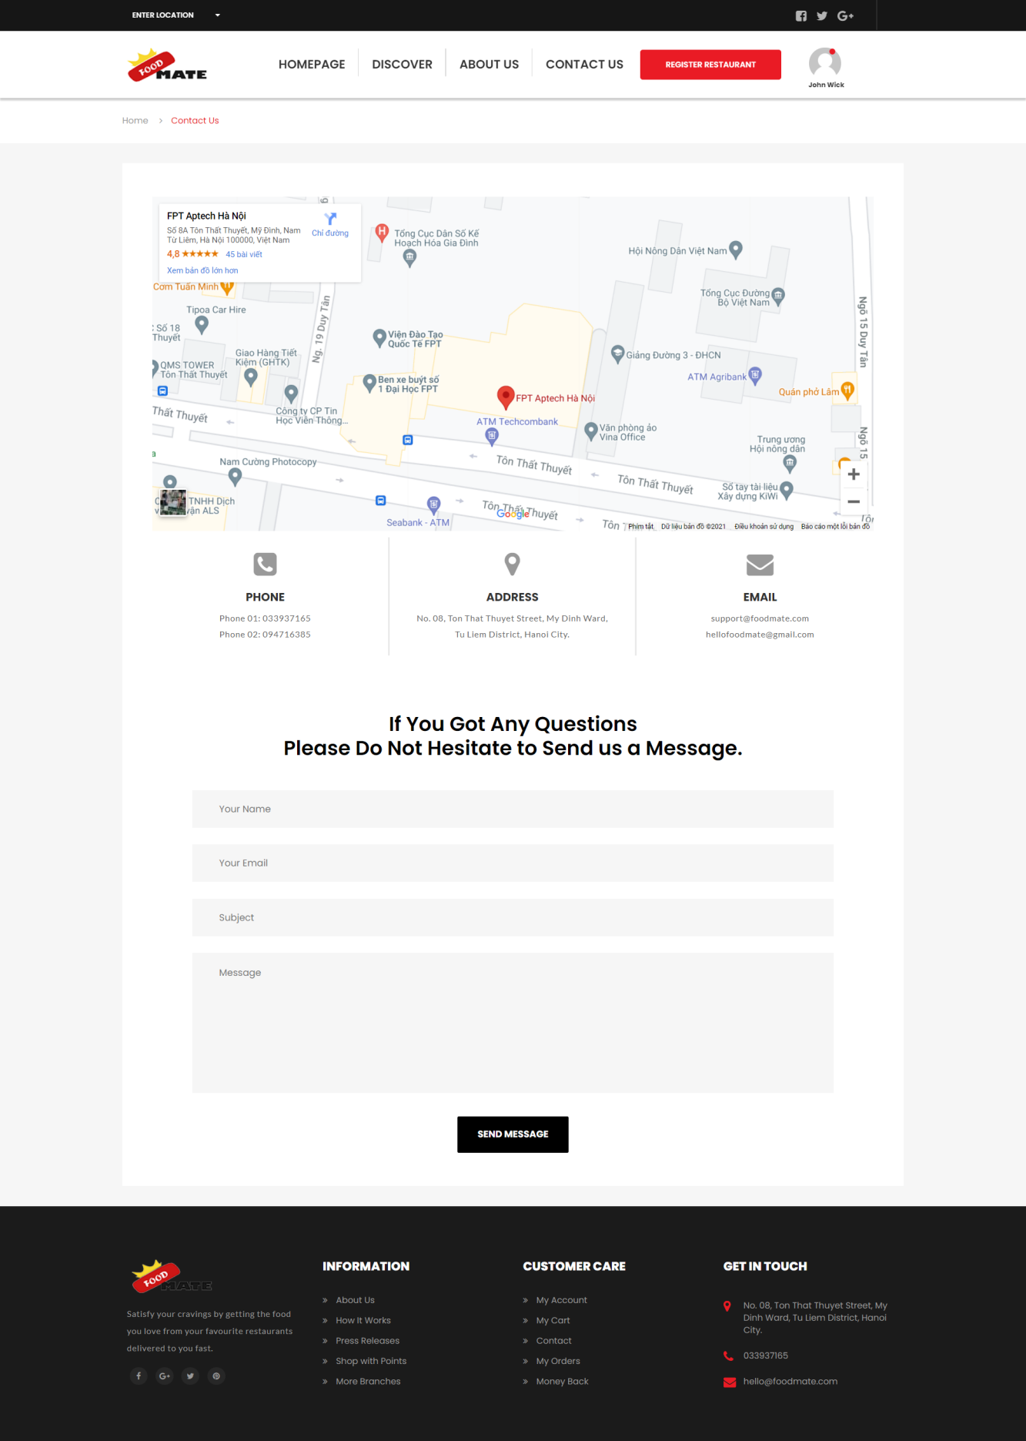

## Register restaurant

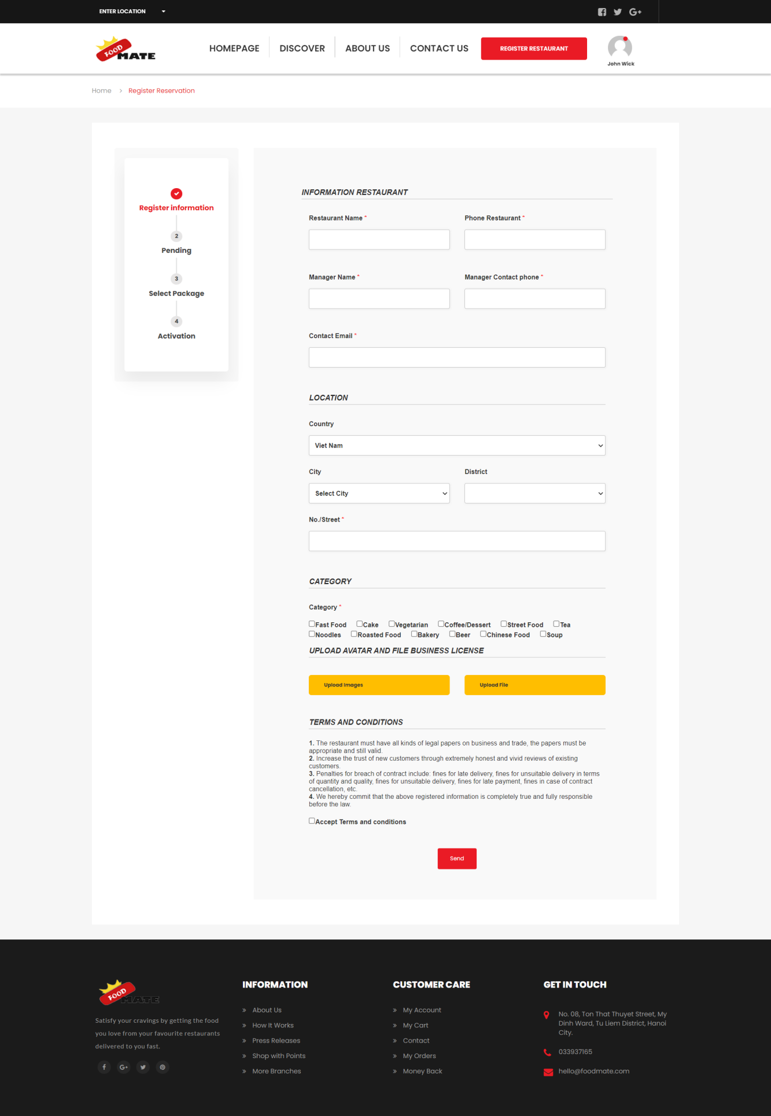

## Restaurant Staff

## Staff dashboard

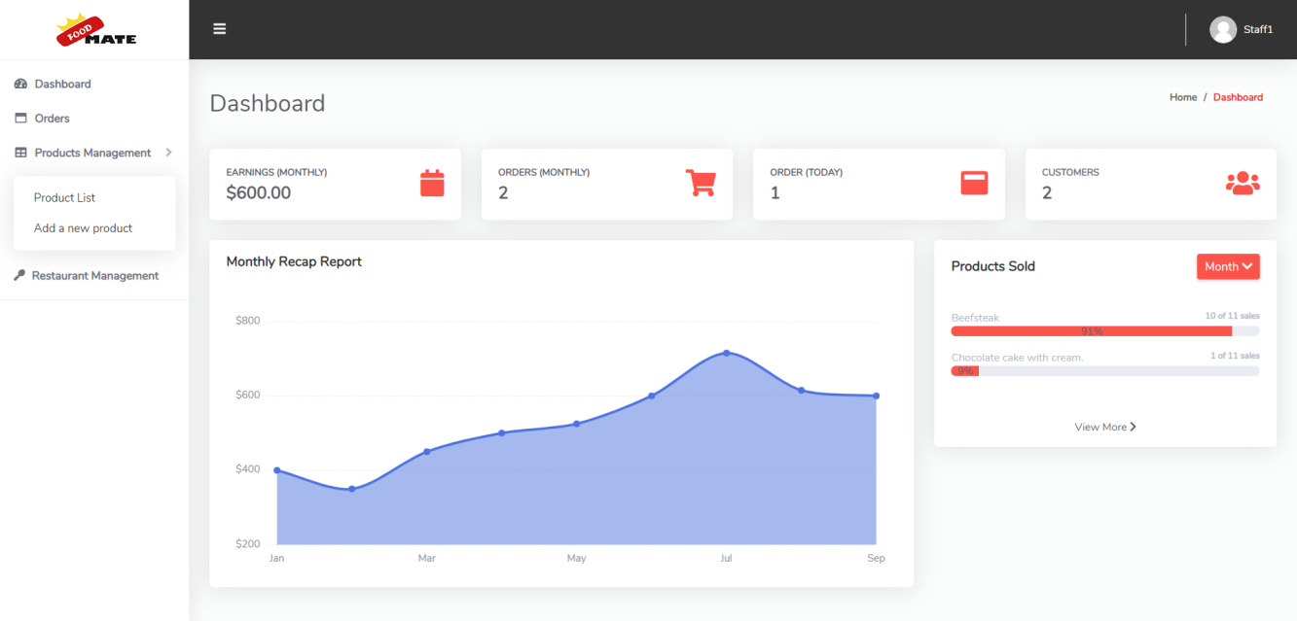

## Staff order list

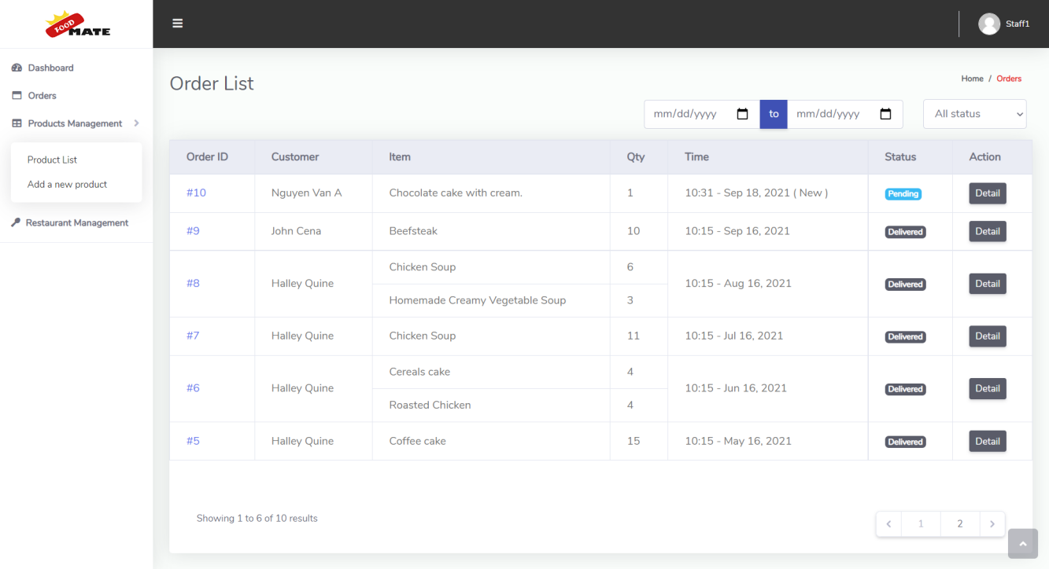

## Staff order detail

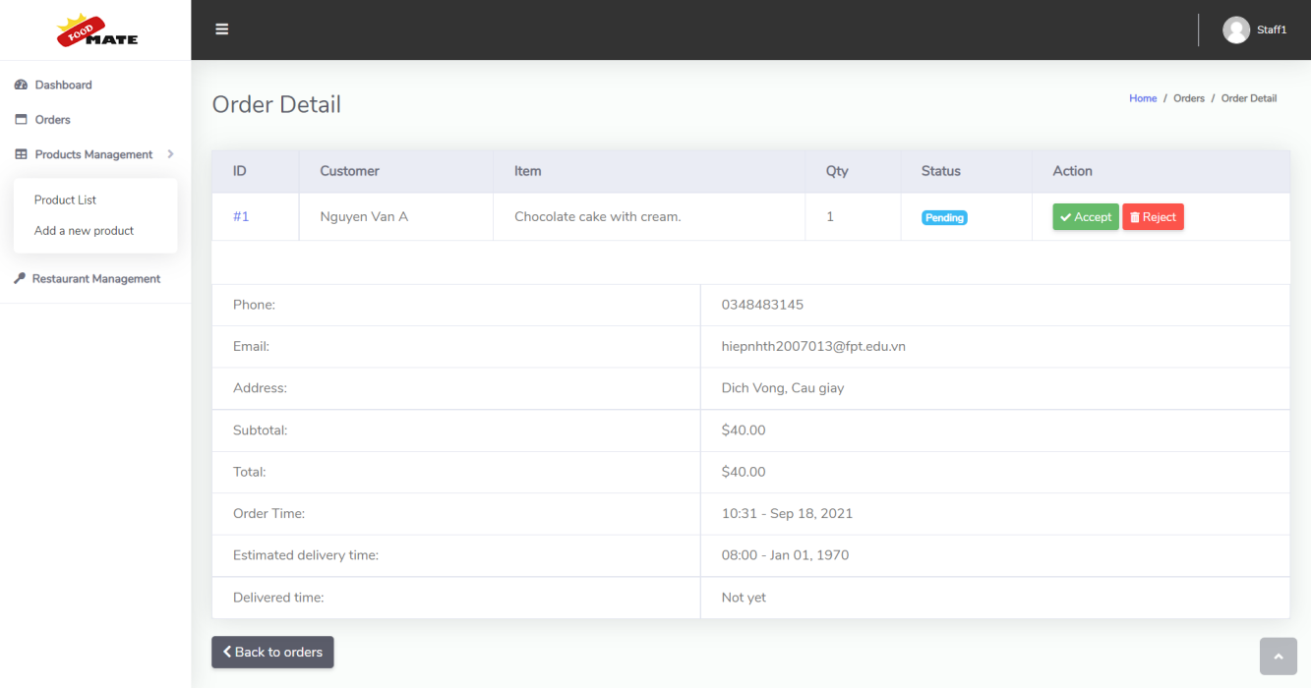

## Staff accept order

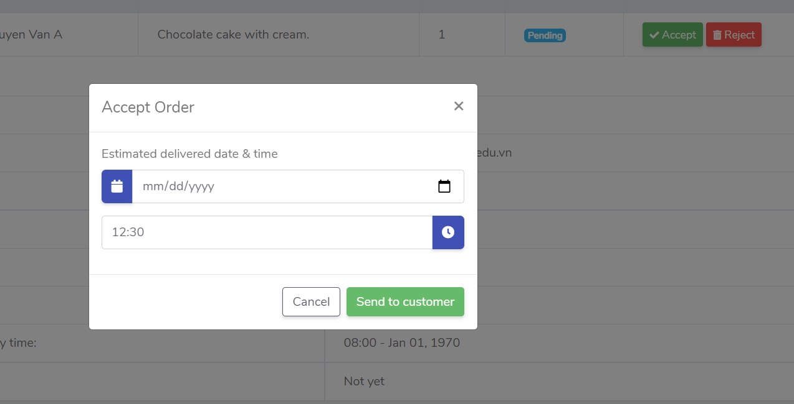

## Staff reject order

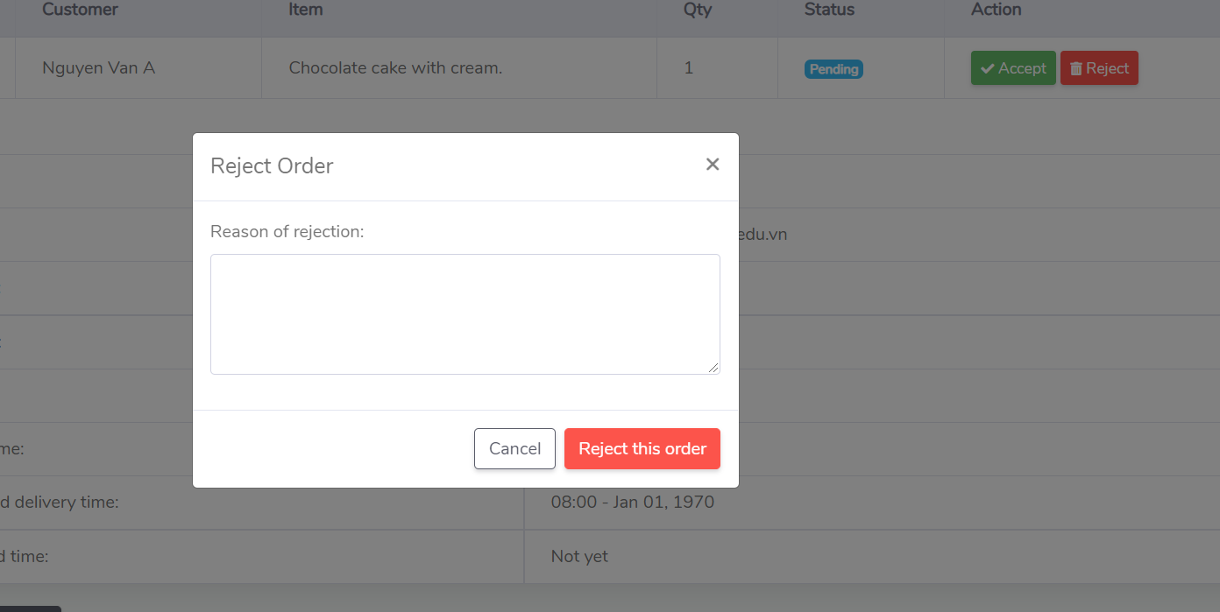

## Staff product list

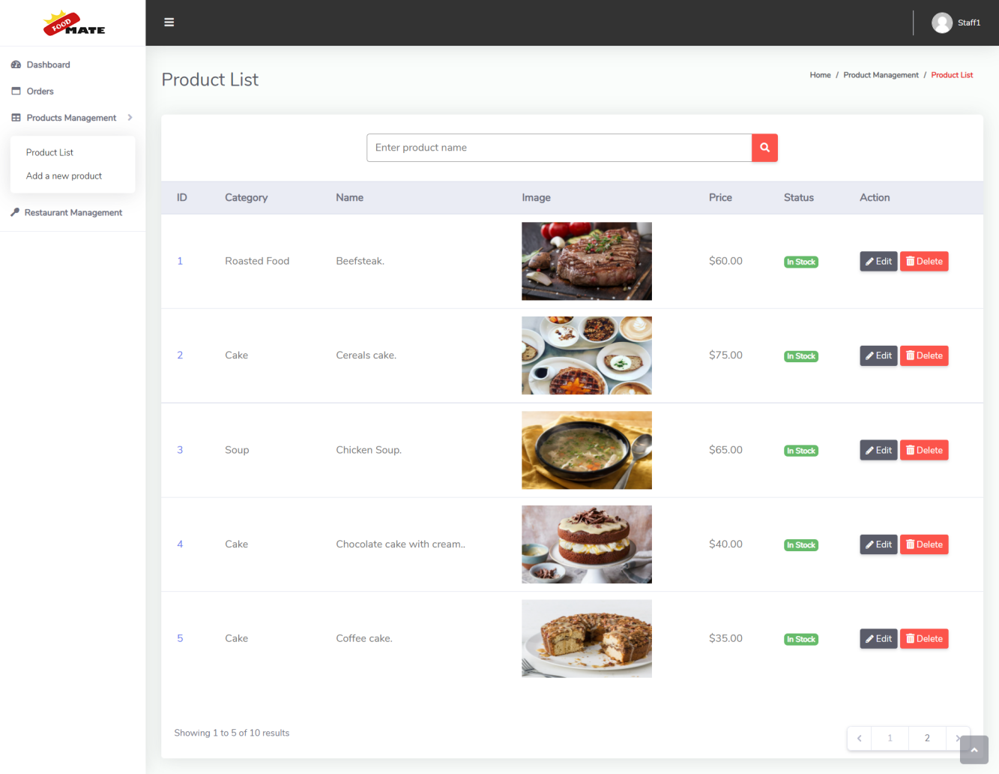

## Staff product edit

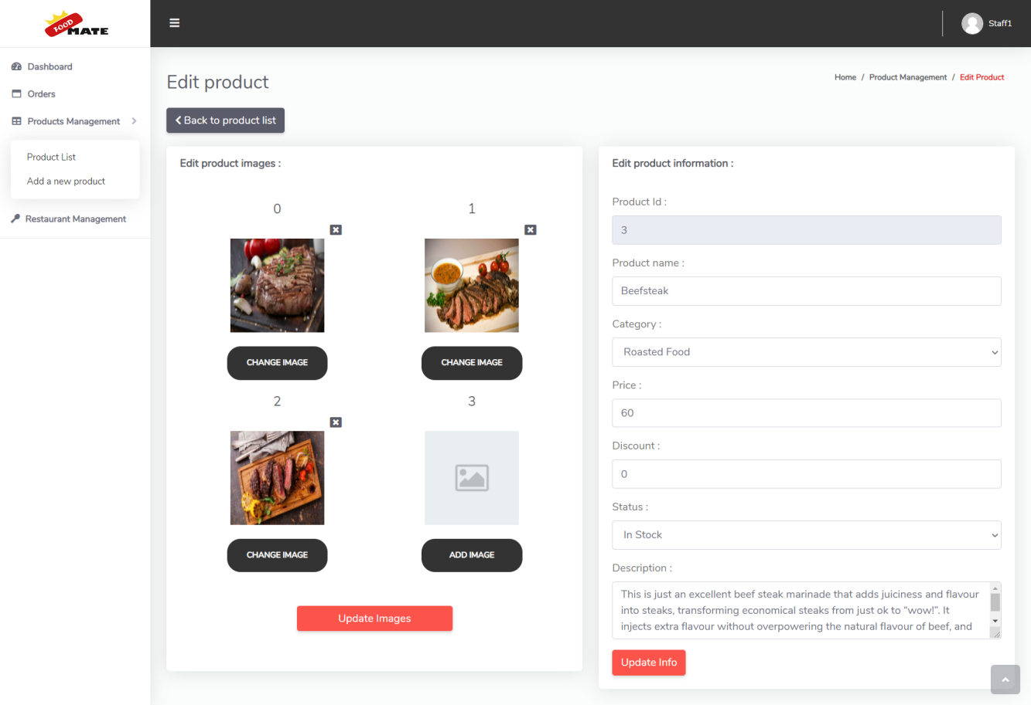

## Add new product

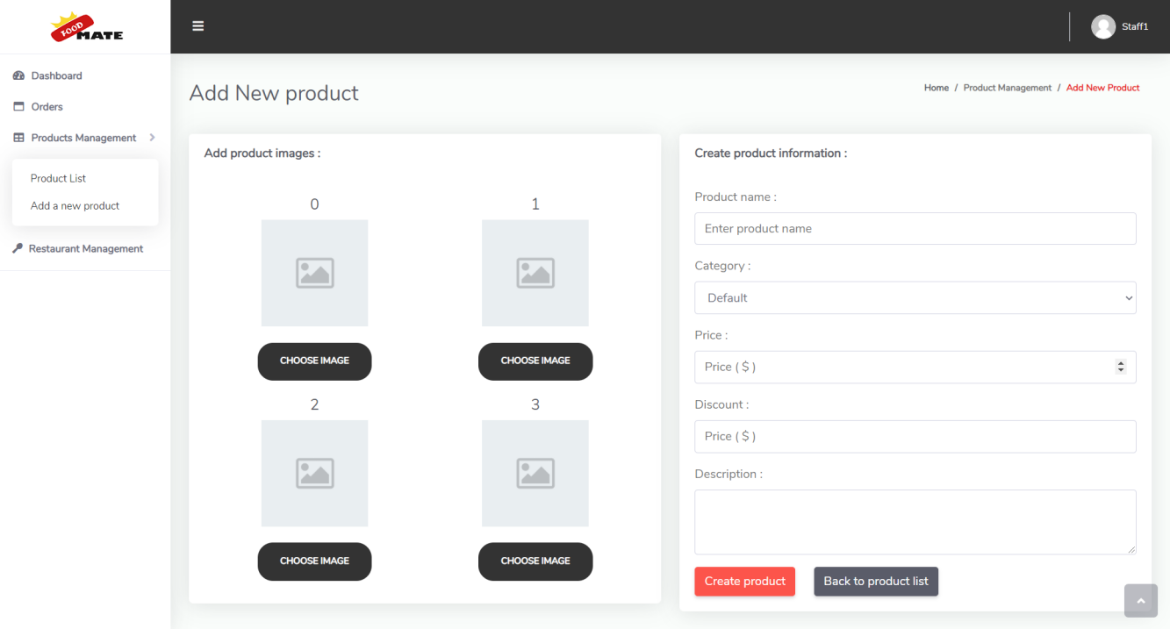

## Restaurant info

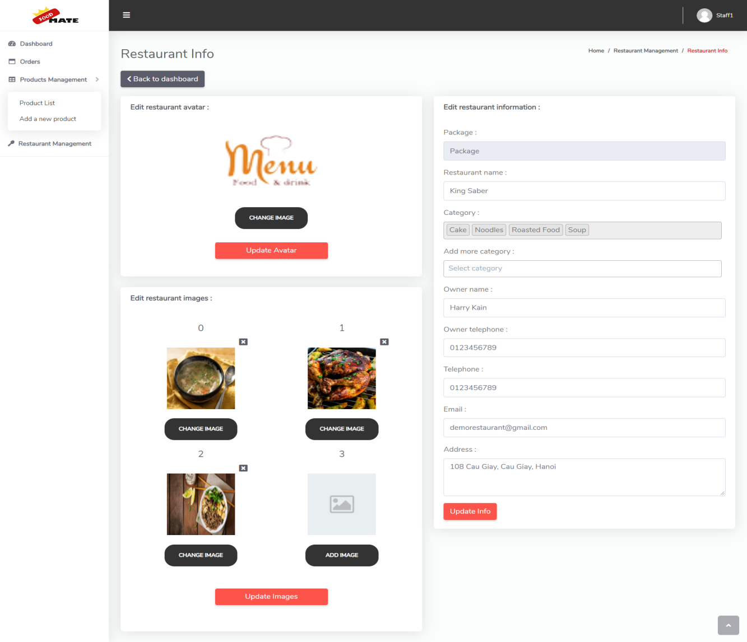

## View earning history

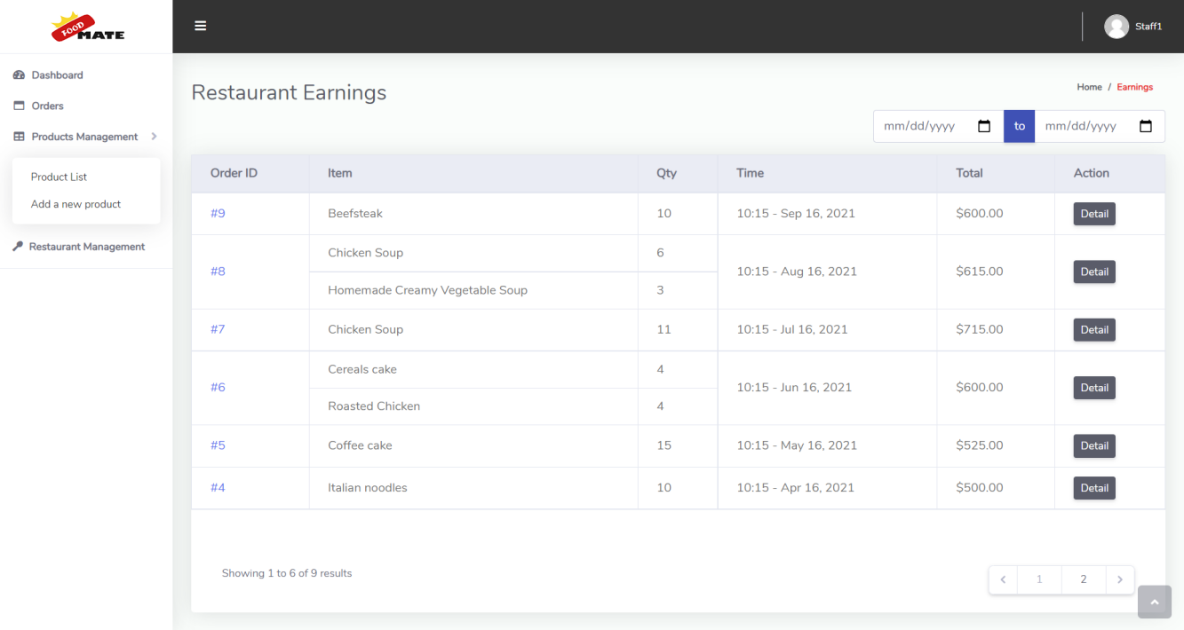

1. **Admin**
2. **Restaurant list**

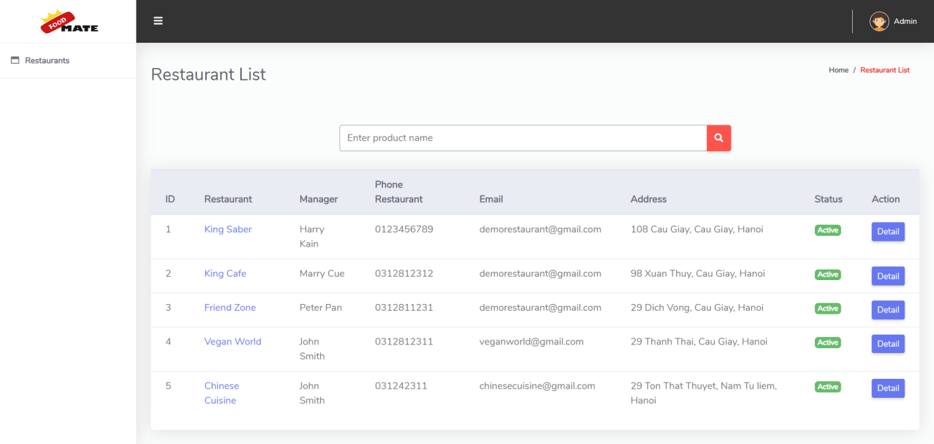

1. **Restaurant detail**

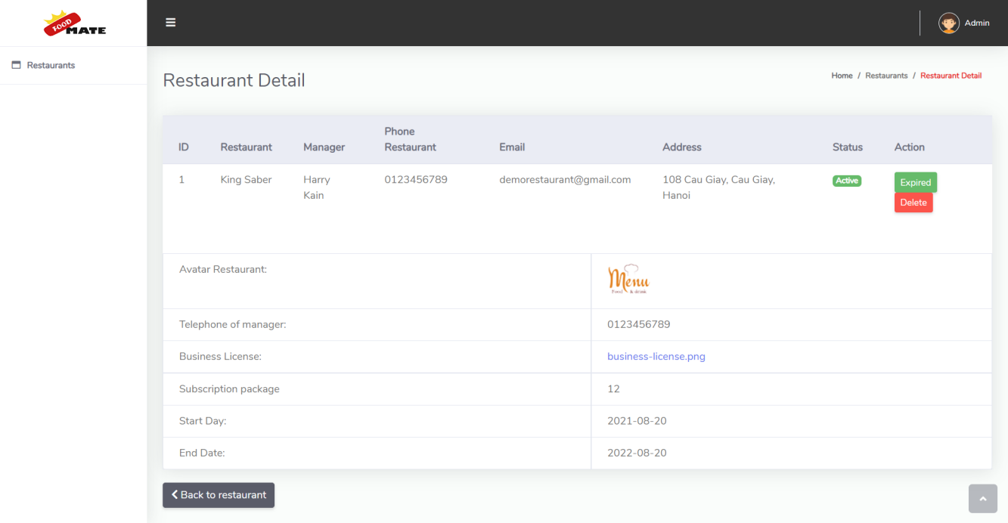

1. **Browse registration**

# 

1. **Delete restaurant**

# 4. **Summary**

The (x) means that person took part in the page(s) include layout / functions or both .

For instance : Tran Dinh Thiem did the Register restaurant page.

|  |  |  |  |  |  |  |
| --- | --- | --- | --- | --- | --- | --- |
|  |  | Tran Dinh Thiem | Nguyen Hoang Hiep | Nguyen Xuan Manh | Nguyen Viet Huong | Hoang Thanh Hai |
|  | Homepage |  | x |  |  |  |
|  | Register restaurant page | x |  |  |  |  |
|  | Find resources & update database |  | x | x |  |  |
|  | Restaurant staff pages |  | x |  |  |  |
|  | Admin pages | x | x |  |  |  |
|  | Product pages | x | x |  |  | x |
|  | Shop |  | x |  | x |  |
|  | Restaurant pages | x | x |  |  |  |
|  | User dashboard pages |  | x |  |  |  |
|  | Contact-us page |  | x |  |  | x |
|  | Login & register |  | x |  |  |  |
|  | About us page |  | x |  |  |  |
|  | Logo | x |  |  |  |  |
|  | How it work | x |  |  |  |  |